FABEC Reports

Tracking

System

By:

Ave Jay Moradillo

Markim Africa

Jhun Michael Tabudlong

|  |  |  |  |  |  |
| --- | --- | --- | --- | --- | --- |
| **Event** | **Trigger** | **Source** | **Use-case** | **Response** | **Destination** |
| Application for new membership | Applicants wants to be a church member | Applicant | Applicant applies for membership | Creates new membership | Council |
| Confirmation for membership | Confirms membership | Applicant | Application confirms his/her membership | Check email to confirm membership | Technical Staff |
| Approval of membership | Approval of membership | Council | Approval of new membership | Creation of new member profile | Technical staff |

**Event Table for Membership**

**Event Table for Member**

|  |  |  |  |  |  |
| --- | --- | --- | --- | --- | --- |
| **Event** | **Trigger** | **Source** | **Use-case** | **Response** | **Destination** |
| Member reports about church events | Regular Assessment of the events performed | Member | Church Leaders assess and records the performed events | Updates the report on church event performance | Council |
| Members submits prayer requests | Prayer requests | Member | Member submits prayer request | Creation of prayer request | Council |
| Tracking of Sunday service attendance | Tracking of Sunday service attendees | Member | Church clerk creates report on Sunday service attendance | Update on Sunday service attendance record | Council |
| Termination of membership | Termination of member | Member | Membership termination and withdrawal | Update of membership records(Inactive) | Technical Staff |

**Event table for Events**

|  |  |  |  |  |  |
| --- | --- | --- | --- | --- | --- |
| **Event** | **Trigger** | **Source** | **Use-Case** | **Response** | **Destination** |
| Approval of proposed event | Member wants to book an event reservation | Member | Members submits Event proposal and Approval of Council | Update church event calendar | Council/Technical Staff |
| Termination of the booked event | Termination of event | Member | Member cancels the proposed event | Update church event calendar | Technical staff |
| Confirmation of the attendance on booked event | Confirmation of member’s attendance | Member | Attendance head count on the event | Update on existing attendance record | Technical staff |

**Event table for Finance**

|  |  |  |  |  |  |
| --- | --- | --- | --- | --- | --- |
| **Event** | **Trigger** | **Source** | **Use-Case** | **Response** | **Destination** |
| Creates a weekly report on tithes and offerings | For keeping track of the total tithes and offerings | Finance | Creation of weekly report on tithes and offerings | Updates the Financial statement/record | Finance dept. |
| Creates a monthly report on church expenses | For keeping track of the total church expenses | Finance | creates a monthly report on church expenses | Updates the Financial statement/record | Finance dept. |

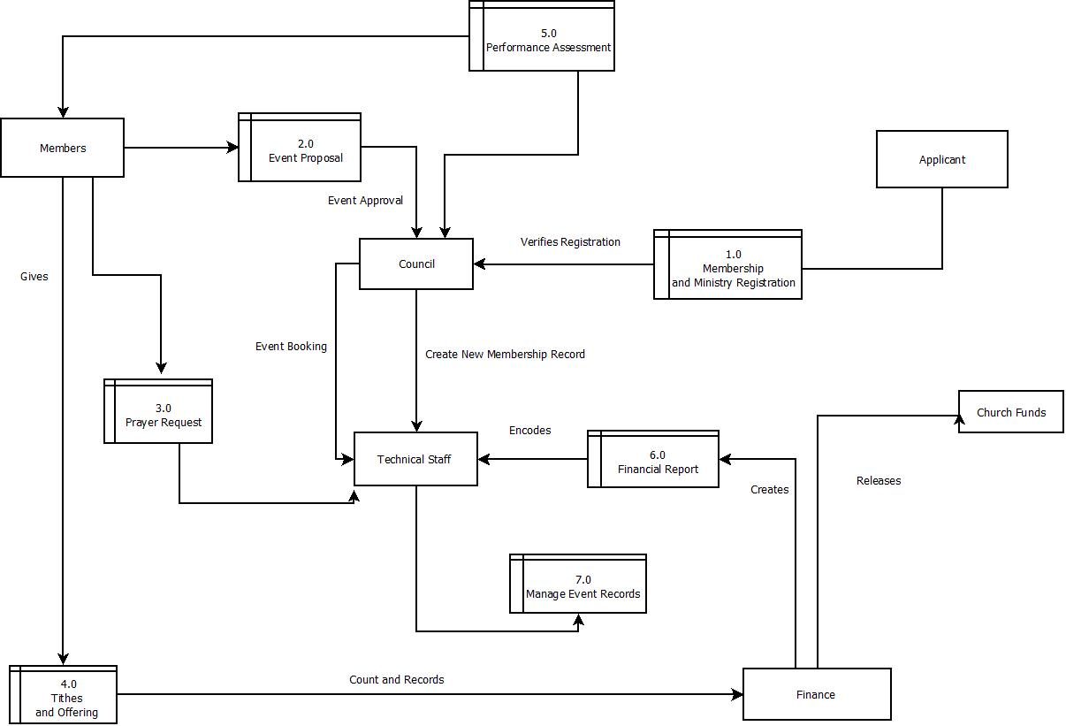

ERD

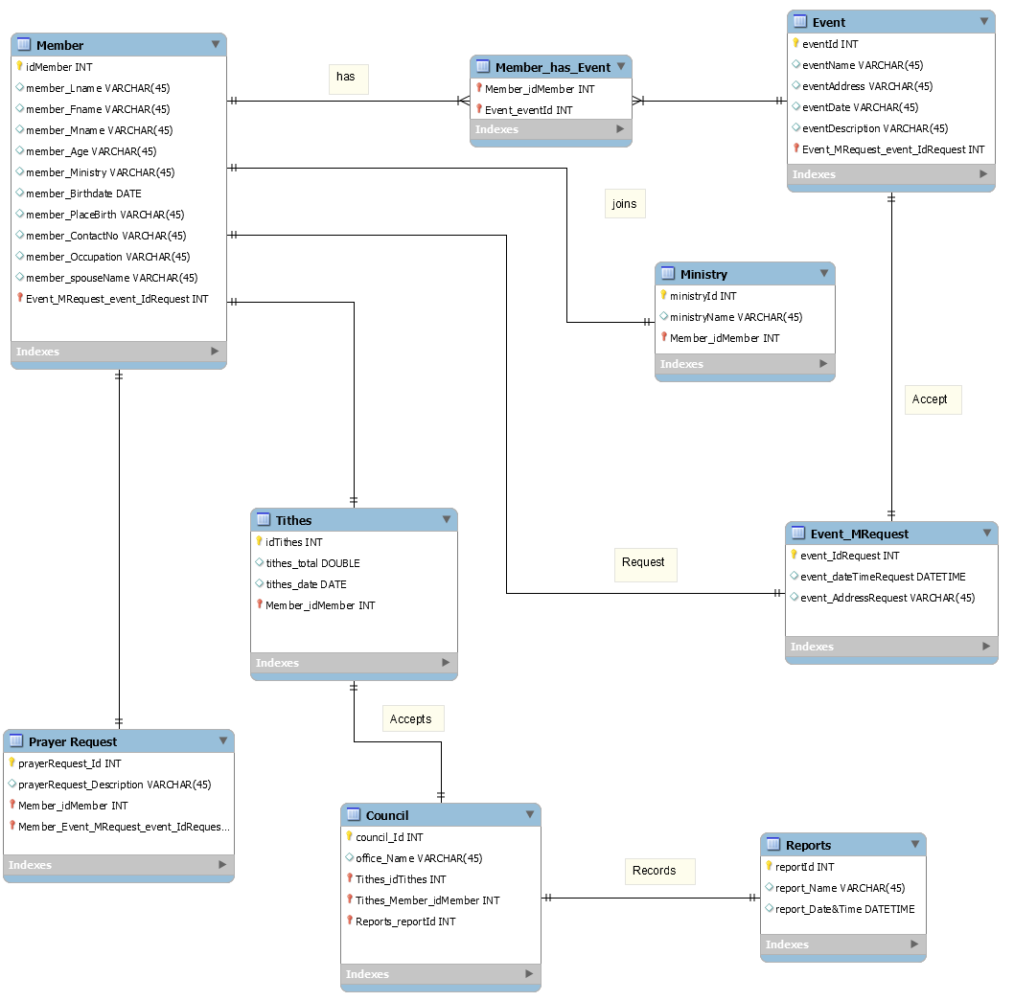

UML

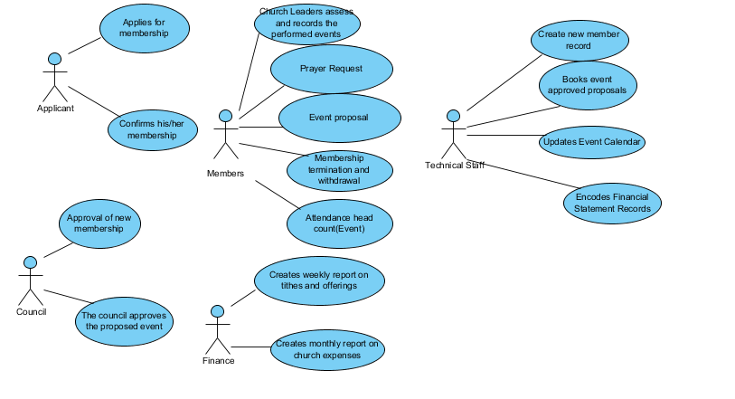

Class Diagram

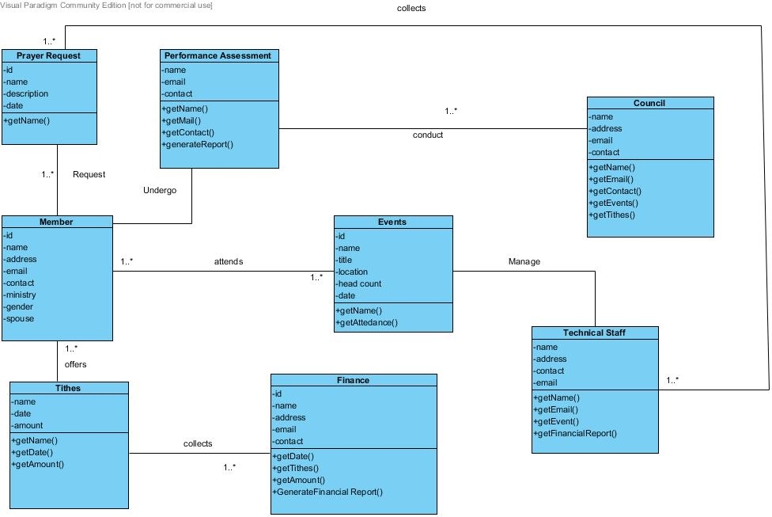

Communication Diagram

Prayer Request

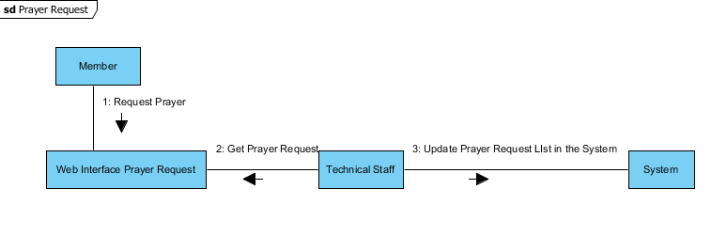

Event Proposal

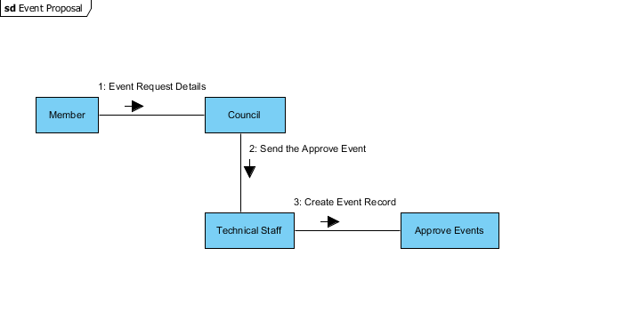

Membership with Application form

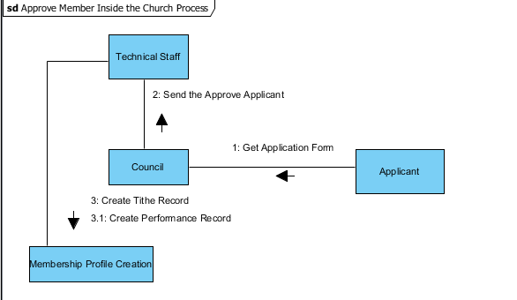

Activation of newly approved member

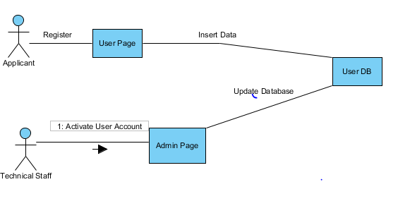

Attendance Record

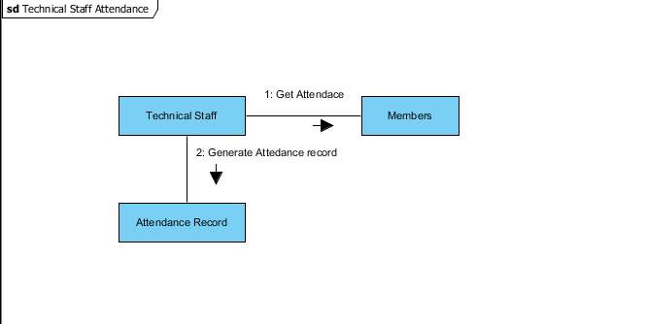

Financial Report

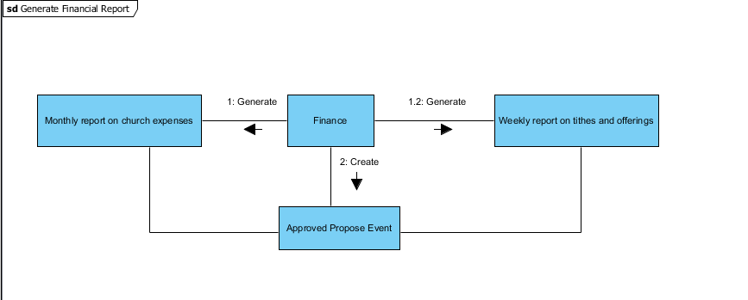

Component Diagram

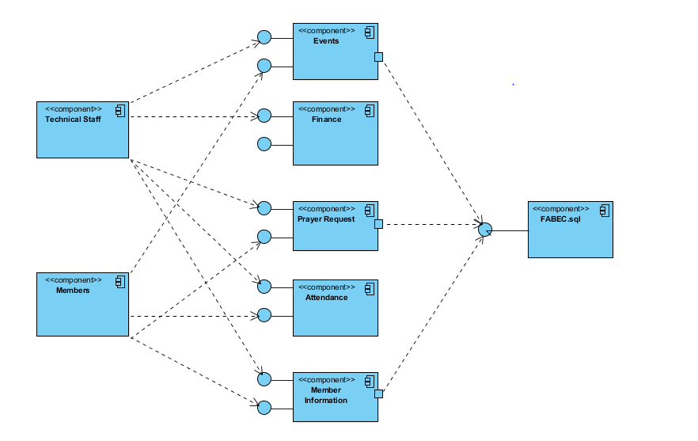

Composite Diagram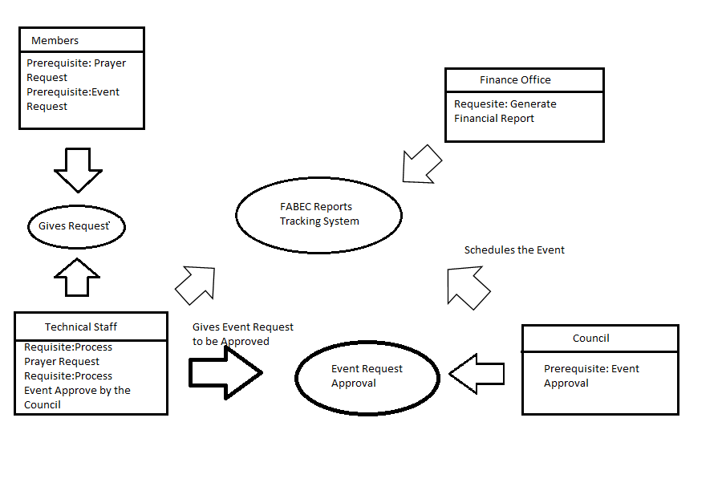

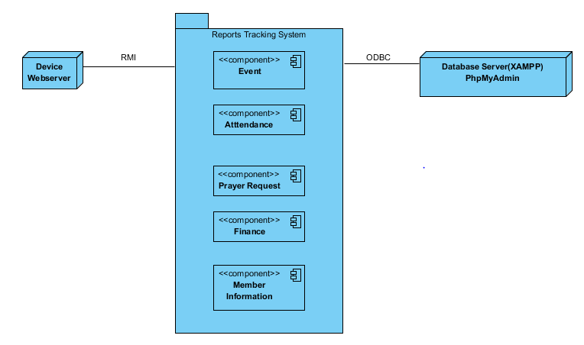Deployment Diagram

Interaction Overview Diagram

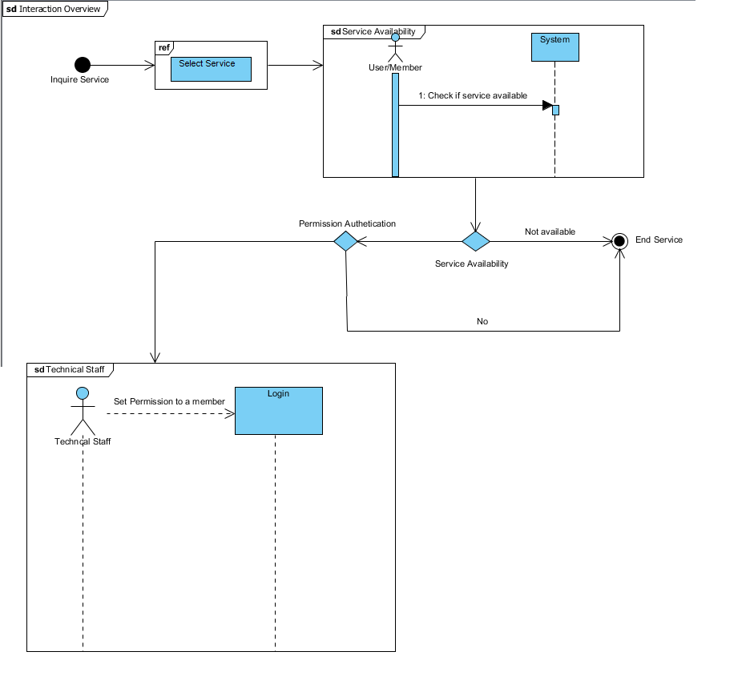

Object Diagram

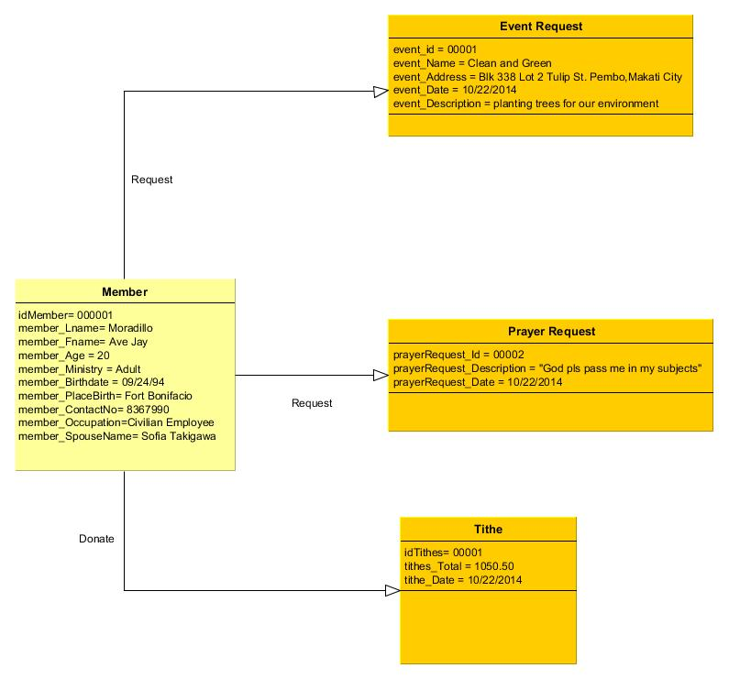

Package Diagram

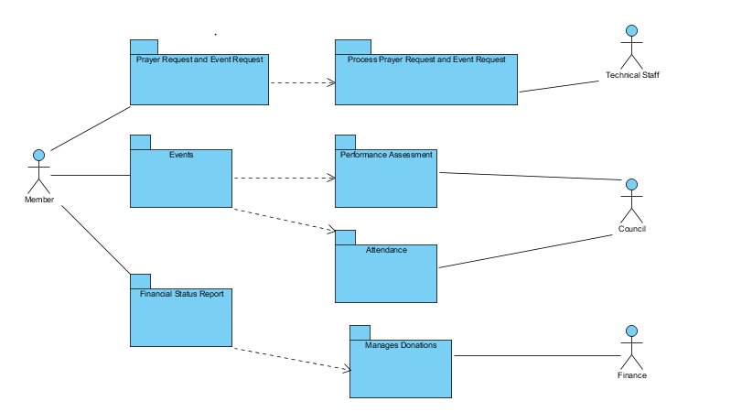

Sequence Diagram

Approve Members

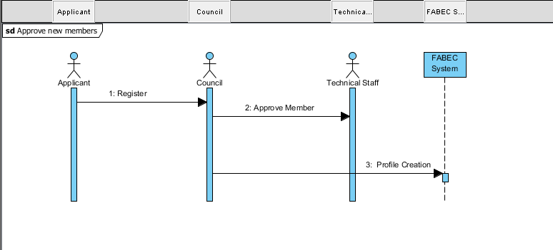

Event Request

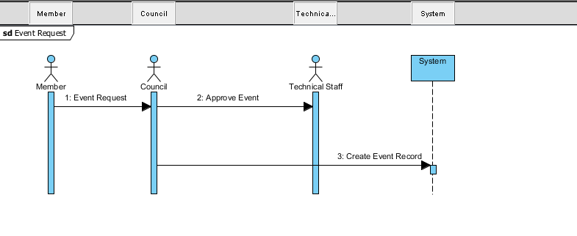

Prayer Request

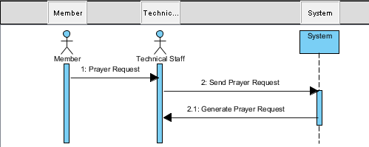

Financial report

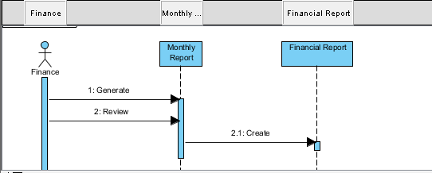

Performance Assessment

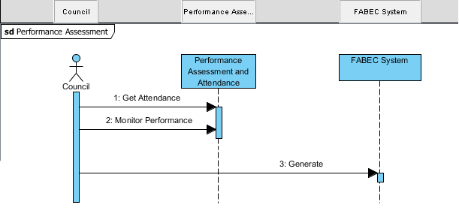

State machine Diagram

Event Proposal & Prayer Request

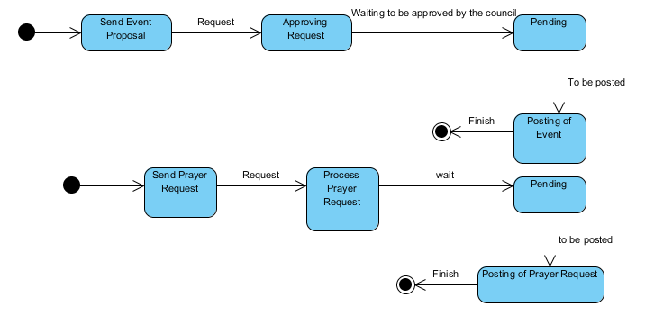

Attendance Record and Financial Report

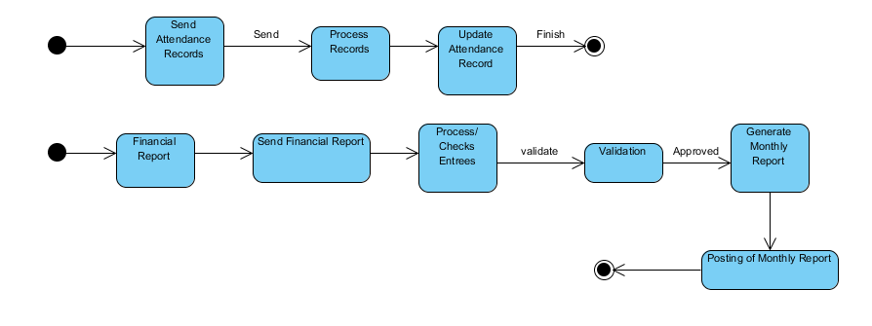

Timing Diagram

Membership Application(Inside System)

Update Member Database

Applicant Register

Create member record

Approve Application

Review Applicant Details

30 minutes 2 days 1 day 30 minutes 30 minutes

Event Member Request

Update Event Database

Create event record

Approve Event Request

Review Event Details

Member Event Request

30 minutes 2 days 1 day 30 minutes 30 minutes

Performance Assessment

Update Performance Assessment in System

Process Performance Assessment Report

Performance Assessment Report

1 day 30 minutes 30 minutes

Prayer Request

Update Prayer Request Database

Create Prayer Request Record

Review Prayer Request Details

Approve Prayer Request

Member Prayer Request

40 minutes 15 minutes 20 minutes 30 minutes 30 minutes

Financial Report

Receive Financial Report

Encode Financial Report

Update Finance Database

Generate Annual Finance Report

30 days 30 minutes 30 minutes 30 minutes